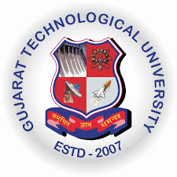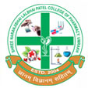
GUJARAT TECHNOLOGY UNIVERSITY
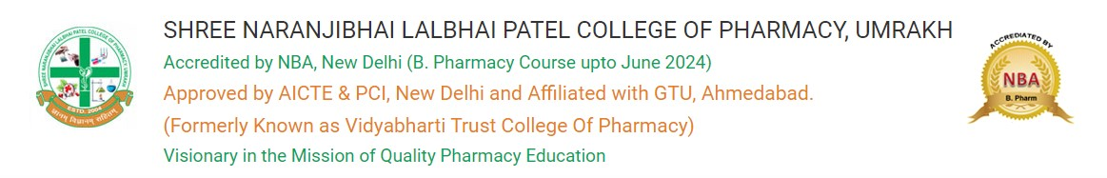

A report on Get Set Goal
Event Name: Creativity, Innovation and Entrepreneurship
Event Date: 8th August 2023
Brief Description of the Event:
The Seminar on "Get Set Goal," organized by the Entrepreneurship Development Cell and SSIP 2.0 at Shree Naranjibhai Lalbhai Patel College of Pharmacy, Umrakh, on 8th August 2023, proved to be an enlightening and motivating event for the 113 students in attendance.
Keynote Address by Dr. Amrut Patel:
Renowned speaker, Dr. Amrut Patel, delivered an impactful keynote address on the importance of goal-setting in personal and professional life. Drawing from his vast experience, Dr. Patel shared practical insights and strategies for defining and achieving goals, captivating the audience with his engaging presentation.
Interactive Sessions:
The seminar included interactive sessions where students actively participated in discussions, exercises, and goal-setting activities. Dr. Patel encouraged students to reflect on their aspirations, identify challenges, and formulate action plans to attain their goals.

Q&A Session:
A lively question and answer session followed Dr. Patel's presentation, allowing students to seek clarification, share their thoughts, and gain additional insights. Dr. Patel's responses provided valuable guidance to the students, fostering a spirit of curiosity and learning.
Networking Opportunities:
The event provided a platform for students to network with Dr. Amrut Patel and among themselves. This networking session facilitated the exchange of ideas, experiences, and contact information, creating a collaborative environment for future endeavours.
The "Get Set Goal" seminar successfully achieved its objective of inspiring and guiding students in the process of goal-setting. Dr. Amrut Patel's profound insights and interactive sessions left a lasting impact on the attendees, motivating them to set ambitious goals and work towards their aspirations. The event not only enhanced the students' understanding of goal-setting but also provided a platform for meaningful interactions and networking.
The Entrepreneurship Development Cell and SSIP 2.0 remain committed to organizing such enriching events that contribute to the holistic development of the students and prepare them for the challenges and opportunities that lie ahead.
This seminar was a significant step towards fostering a culture of goal-oriented thinking and personal development within the academic community. At last world. Dr. Soanl Solanki concluded the session with vote of thanks.
